Module 4 – Forecasting and cancellation Trends
This dashboard focuses on future booking behavior, specifically:
- how occupancy is expected to change,
- how cancellations behave over time,
- how early customers book (lead time),
- and how refunds/no-shows impact financial planning.
Together, these visuals allow a forward-looking view, instead of only descriptive analytics.
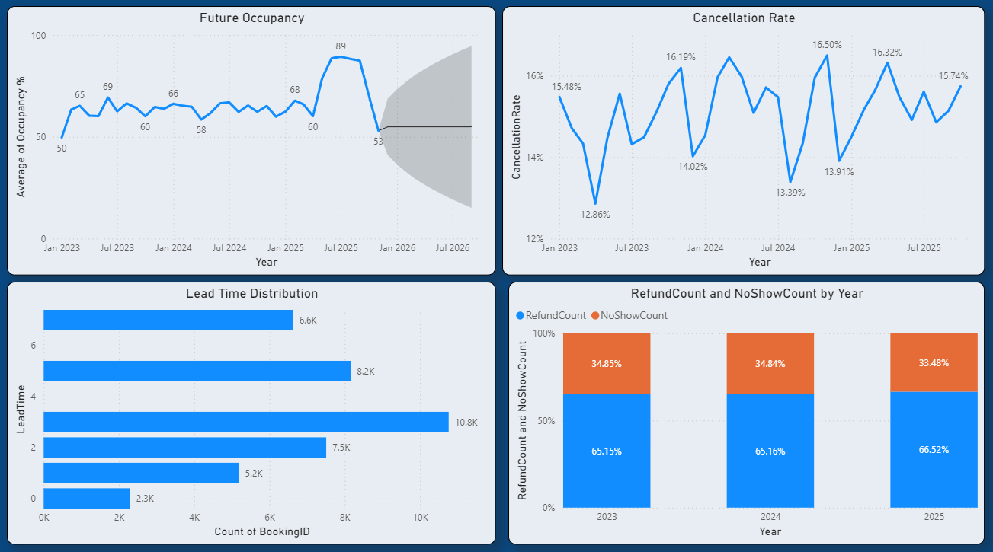

1. Forecasting – Trend Lines & Seasonal Decomposition
Visual: Future Occupancy (forecast + confidence band)
- The blue line shows historical occupancy %
- The grey shaded area is the forecasted upper and lower confidence range
- You can clearly see seasonality—peaks during certain months
- A strong spike around mid-2025 followed by lower months

Concepts explained:
✔ Trend – long-term increase/decrease
✔ Seasonality – repeated yearly pattern (festivals, holidays, travel seasons)
✔ Forecasting — model extends future values based on historical patterns
If seasonal decomposition were shown analytically it would separate:
- Trend component
- Seasonal component
- Residual noise
Interpretation
Demand is expected to rise sharply mid-2025 then moderate, allowing proactive inventory & pricing planning.

2. Cancellation Rate
Visual: Time-series % line chart with labels
Formula:
Cancellation Rate= (Cancelled Bookings/Total Bookings) × 100
Insights:
- Cancellation fluctuates between ~13% and ~16%
- Seasonal peaks occur periodically
- Higher values visible during typical vacation planning months
- Lower during off-season
If shown as a bar:
- Each month can be compared easily
- Helps highlight peak cancellation periods
Business Interpretation
Consistent cancellation % suggests predictable behavior → good candidate for forecasting & operational planning.

3. Lead Time Distribution – Histogram
Visual: Horizontal bars grouped by Lead Time days
Lead Time = number of days between booking date and stay date.

Observation:
- Most bookings fall in 2–4 days lead time
- Fewer extremely early bookings (6–7 days)
Interpretation
Hotels receive most bookings only a few days before the stay → pricing & room allocation must be dynamic.

4. No-Show / Refund Trends
Visual: 100% stacked chart by year
- Shows the share of Refund vs No-show each year
- Each bar = 100% distribution of booking failures
Key takeaway:
- Refunds make up ~65%
- No-shows ~35%
- Ratio is consistent across years
If displayed as a line chart:
- You could visually detect increase/decrease over time
- Trend detection becomes easier across future years
Interpretation
Refund rate is predictable, so budgeted reserve can be estimated in advance.

5. BUSINESS IMPACT – Proactive planning & Risk Management
This dashboard enables decision-making around:
✔ inventory forecasting
✔ cancellation prediction
✔ revenue assurance
✔ refund provisioning
✔ overbooking strategy
✔ price optimization
✔ targeted marketing for low seasons

Operational Strategies Enabled:
- Predict high demand periods → increase rates
- Identify low occupancy → offer discounts/ campaigns
- Pre-allocate refund funds based on expected ratios
- Reduce no-shows by sending reminders pre-arrival
- Dynamic cancellation policy (season + booking window)
Financial Stability
Predicting cancellations and refunds helps:
- minimize revenue leakage
- reduce unsold room losses
- optimize staffing and housekeeping scheduling

This dashboard visualizes forecasting and cancellation behavior through occupancy forecasting, cancellation percentages, lead time booking patterns, and refund/no-show ratios. Using trend lines, seasonal decomposition ideas, and distribution analysis, it enables hotels to proactively plan inventory, minimize revenue loss, manage cancellations intelligently, and implement strategic pricing based on forecasted demand patterns.

